**CHAPTER 4**

**MATHEMATICAL MODEL OF VARIABLE SPEED FREQUENCY CONTROLLED INDUCTION MOTOR (ABC-αβ)**

The reference coordinate models have a very wide area of application. But, they are not appropriate for studying unbalanced operation of the motor especially when frequency is controlled in the PWM inverter. In many practical problems one faces the situation where only variables of the stator (rotor) and electromagnetic torque are of interest while the variables of the rotor (stator) are of no significant importance. The reference coordinate model (α-β) cannot be easily applied if there is complex unbalance of the stator (rotor) circuit. When studying drive/motor interactions during autorecloseing operations it is important to consider the effects of the PWM inverter.

Result obtained for an induction motor with Rs=0.2Ω, Rr=0.3 Ω, Lm=16 Ω, and Ls=Lr=16.55 Ω, fed with a fundamental frequency fn=60 Hz, at a switching frequency fc=1260 Hz and sinusoidal PWM, are shown in fig-4.1.

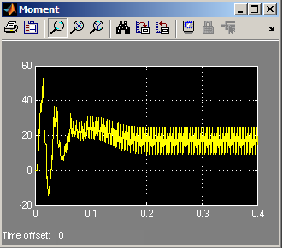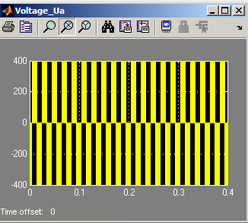

1. (b)

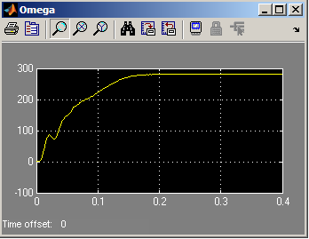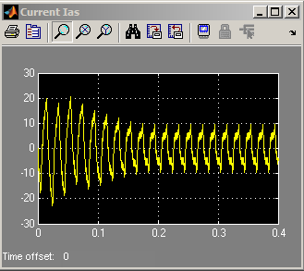(c) (d)

Fig-4.1 computed waveforms for sinusoidal PWM scheme (a) voltage Va (b) electromagnetic torque Te (c) current iA (d) angular velocity ωr

In this case the ABC/αβ reference frame can be used which preserves the stator states in their original form, while only transforming the rotor states to d, q axis variables. A schematic of the induction motor with ABC/αβ axes shown is in Fig-4.2.

In this model, the α-axis coincides with phase A of the stator while the β-axis leads the α-axis by 90° (electrical). The differential equations of the ABC/αβ model can be obtained by applying two transformations in cascade to the ABC impedance matrix. At first, the balanced three phase rotor winding is transformed to a two phase α'-β' equivalent frame which is stationary relative to the rotor (axis α' coincides with the rotor phase A axis). Then the α'β' frame is transformed to the α-β reference frame which is stationary relative to the stator.

For stator coordinate θb=0; It is usual to align the α' axis with the phase “a” rotor winding. This implies that α'-β' frame is fixed to the rotor. The transformation from abc to αβ0 variables are given as



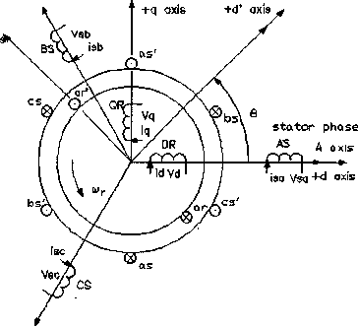Fig-4.2 the schematic diagram of a 3-phase induction motor for ABC-αβ model

 (4.1)

So,





The rotor currents for α-β are as follow;





The voltage equations for stationary reference frame (α-β),

 (4.2)

The flux linkage of the ABC-αβ model is;



 (4.3)

The matrix form of the voltage equation for stator and rotor voltages in the ABC-αβ model;

 (4.4)

  

 

Expressions for vq, vd depend on the frequency of applied rotor voltage. If the frequency is equal to the slip frequency then

  (4.5)

Where, Vmr is the peak rotor voltage. s is the slip of the motor.

The expression for electromagnetic torque in the ABC-αβ model is as follows;  (4.6)

Unlike the phase coordinate model (ABC model), the inductance matrix is time invariant and does not need to be inverted during each step of integration. Therefore transients can be simulated much faster with the advantage that stator variables coincide with physical stator variables of the motor.

For inverter excitation and mechanical steady-state (ωr = const.) based on VA(t), VB(t), VC(t) functions, as imposed by the corresponding inverter strategy, the currents may be found from (4.4) under the form

 (4.7)

Initial values of currents are to be given for steady state sinusoidal supply and the same fundamental. When the speed varies, the PWM switching patterns may change and thus produce current and torque transients. A smooth transition is needed for good performance. The ABC-αβ model, including the motion equation, also can detect this transition and serves for this purpose.

**4.1 Vector model of induction motor taking into account the null sequence**

If the stator of machine has neutral conductor, then phase currents can contain zero component and their values it is possible to represent in the form, and. Then the vector of current is equal

 (4.8)

 (4.9) 

Kirchhoff's equations for the phase primary voltages AD

 (4.10)

Kirchhoff's equations for the phase voltages of rotor 3m



 (4.11)

Thus, the generalized vector of armature current does not contain zero components and it during the analysis should be considered separately. If phase currents contain zero component, then its value will be equal  or. For phase of the value of armature currents, either  and for phase of the value of the currents of rotor, or. In the phases of stator-rotor unit, the current of null sequence is created correspondingly transformation EMF.

For the symmetrical regimes, and also in the absence neutral particles in star or connection of the windings by triangle in the system of equations (2.60-2.63), current  it is excluded. [ 14 ]

**4.2 Phase coordinate Model under Saturation Effect**

The differential equations of the saturated machine are very much similar to that at unsaturated machine.

For the  coordinate system, the stator equations under saturation effect are as followed; 

 (4.12)

Equations of the short-circuited rotor under saturation effect

 (4.13)

For the flux linkage and the currents equations:

 (4.14)

 (4.15)

For magnetization current, iμ

 (4.16)

If we differentiate on equations (3.51)

 (4.17)

The flux linkage equations are obtained from eq (3.52)

 (4.18)

The rate of change of iμ becomes,

 (4.19)

If we substitute eq (3.46) in eq (3.52), the static and dynamic flux density Bs and Bd are obtained,

  (4.20) As a result we obtain

 (4.21)

Where,

  

 (4.22)

To obtain the solutions, the differential equations are solved by Numerical Analysis.

**4.3 Calculation of steel losses by equivalent circuits**

In the phase coordinate model (ABC), the steel losses effect is neglected to obtain simplicity. But in frequency controlled induction motor, the steel losses effect should be included as the speed of the motor is controlled increased as the controlled frequency is increased. So, in this model the effect is made to include steel losses effect.

For induction motor series 4A, the steel losses is more than 20% of total losses in rated operating mode and more than 50% of total losses in no load condition. Therefore, if we don’t include this effect, accuracy of our model is decreased.

In this thesis, the effect of steel losses is analyzed based on two equivalent circuits.

1. The series connection of steel losses resistance Rm with magnetization impedance Xm (fig a)

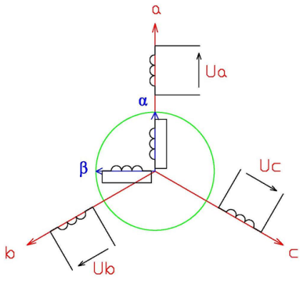

Fig-4.3 Schematic of the model of three-phase induction motor in the system (ABC-αβ)

2. The parallel connection of steel losses resistance Rc with magnetization impedance Xmμ (fig b)

The Resistances Rc and Xm can be easily calculated from Rm and Xm as followed;

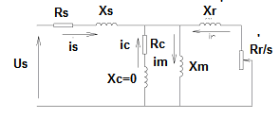  ,

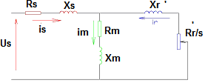 (a)

(b)

Fig-4.4 Equivalent circuits of induction motor under steel losses effect

1. Series connection of Rm with Xm (b) Parallel connection of Rc with xmμ.

However the relationship between Rm and frequency f is not linear. The approximate equation is . So the equation of Rm becomes, where - steel losses resistance when f = f0. The Resistance Rc according to equation (3.57) also depend on frequency, but they are not linear too. The relationship of Rc and f is. Therefore, . The relationship between Rm ,Rc and f are illustrated as shown in fig-4.5.

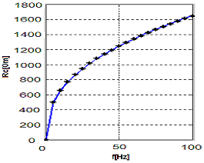 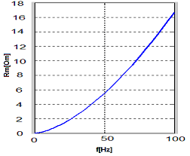

Fig-4.5 relationship between Rm, Rc with f

**4.4 Mathematical model ABC-αβ under steel losses effect**

In article 4.3, steel losses are calculated by introduction of steel losses resistance Rm in equivalent circuit. This model is approximate for steady state analysis. However, the mathematical model including steel losses effect is needed for transient analysis of introduction motor. So the differential equations of ABC- αβ are modified by including the effect of steel losses resistance Rm .

The vector form of the voltage equations under steel losses effect are as follow;

 (4.23)

 (4.24)

- stator and rotor current equation

The electromagnetic equation is

 (4.27)

In the symmetrical three-phase system, the vector form of current equations under steel losses effect can be written as follow;

 (4.28)

 (4.29)

 (4.30)

Kirchhoff’s equation for stator and rotor currents in the ABC-αβ model,



(4.31)



(4.32)



(4.33)

 (4.34)

 (4.35)

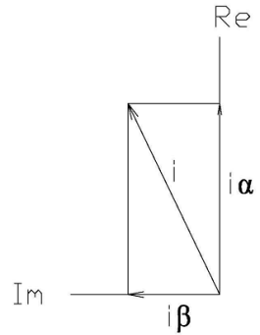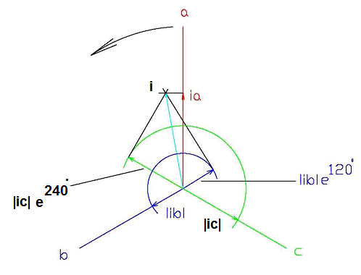Fig 4.6 shows the vector diagram of stator phase (ABC) and rotor phase (αβ).

(a) (b)

Fig-4.6 Vector diagrams of (a) stator phase ABC and (b) rotor phase αβ

Kirchhoff’s equations for stator and rotor voltages of the ABC- αβ model under steel losses effect,

 (4.36)

Where,   



Electromagnetic torque equation is as follows;

 (4.37)

The angular velocity equation is

 (4.38)

The flux linkage equations of the ABC-αβ model under steel losses effect are as follow;

 (4.39)

The above system can be used to analyze the frequency controlled induction motor including steel losses effect.

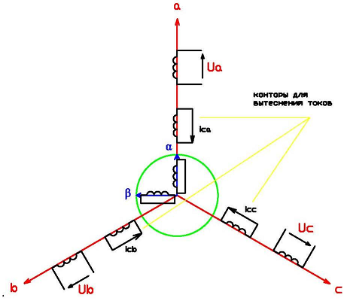**3.6 modification at mathematical model ABC-αβ by including eddy current effect** In this system, the eddy current effect is included by adding three loop in stator phase A, B and C.

Fig-4.7 Schematic diagram of mathematical model (ABC-αβ) under eddy current effect

The system of differential equations is as shown below;

; - the stator voltage equation (4.40)

; - the rotor voltage equation (4.41)

; - eddy currents loop voltage equation (4.42)

 - the stator flux linkage equation (4.43)

 - the rotor flux linkage equation (4.44)

 - flux linkage equation for eddy current effect (4.45)

 - mutual flux linkage equation (4.46)

 - the current equations (4.47)

The stator and rotor voltage equations are as shown below;

 (4.48)

The eddy currents loop voltage equations are as follow;



 (4.49)

The electromagnetic torque equation under eddy current effect is

 (4.50)

The angular velocity equation is

 (4.51)

The current and flux linkage equations are as follow;

 (4.52)

 (4.53)

 (4.54)

The above system of equation can be used to analyze transient analysis of frequency controlled induction motor under steel losses and eddy current effects. The results are verified with well known alpha-beta system results and almost identical. Therefore above model will be standard model for inverter-fed induction motor.

**Conclusions**

In the proposed structure of mathematical models, describing work system PCh- hell, that consider the effect of current displacement in the conductors of the rotor winding, saturation of magnetic circuit, law of control of invektorom SHIM;

The developed procedures and the programs of the calculation of the transient operating modes make it possible to in detail investigate the influence of the form of input voltage AD and the parameters AD on its energy indices at the nourishment from the frequency converter.

As a result of the comparison of different criteria of optimality, on the basis of the carried out optimization calculations, are given the recommendations regarding the selection of construction AD with the short-circuited rotor, that work together with the static converters.

Is developed the mathematical model of the frequency adjustable engine in the axes (a.b.ch, (bv)), in which the losses in steel are considered, and the influence of saturation and current displacement is considered with the aid of coefficients of Kmu, K r and Kx. Are represented the dependences of the effective resistance of the magnetizing outline of equivalent to losses in steel on the frequency of reversal of polarity.